**2015-02-30 Primersekvenser:**

Primerpar för PCR D ( primers i D9539 resp 53612):

feces_ 53612 _Long rev 1_rev/kompl:5´ GGTCGAATCGTCAGCATATCAAAGATGT **3´**

feces_ D9539 _Long fw 2:5´ CTGATAATCCTTTGCCTTCTGGTGG 3´

Primerpar för PCR C ( primers i D9539):

feces_ D9539 _Long rev 2_rev/kompl:5´ GCATAATCTGACTGAAAAAGCAGCAGTAC **3´**

feces_ D9539 _Long fw 2:5´ CTGATAATCCTTTGCCTTCTGGTGG 3´

**2013 Primersekvenser och gelbilder**

**Markör:** 1 kb DNA ladder (bortse från markören först och sist på gelen)

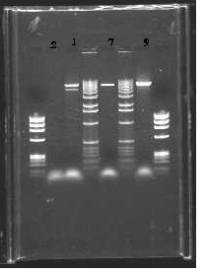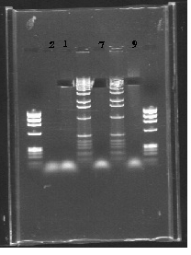

**1. EE5WR**

**2.** NTC

**7. D9539**

**9. H8MH7**

**GB3LKKR01EE5WR / cluster211b**

**GB3LKKR01EE5WR primers för gelen på bilden:**

feces_ GB3LKKR01EE5WR _Long rev: **GTAAACTTTCTGTTGCAGGTTCAGCG**

feces_ GB3LKKR01EE5WR _Long fw: **CCTGTGTTTATCGGAGGTATGACACAA**

**Andra primersekvenser som använts för sekvens GB3LKKR01EE5WR:**

|  |  |
| --- | --- |
| feces_ GB3LKKR01EE5WR _**30 F** | **CGCTGAACCTGCAACAGAAAGTTTAC** |
| feces_ GB3LKKR01EE5WR _**179 R** | **TTGTGTCATACCTCCGATAAACACAGG** |
| 6/11_feces_ EE5WR+sekvens _ **R** | **TGTGTAGGTACGGAAGTGGACGTAC** |
| 6/11_feces_ EE5WR+sekvens _ **F** | **CCACCAATCAAACTATCACAGGGCAG** |
| feces_ EE5WR+sekvens _ **4000 bp band_ F** | **GCTTAGGGCGAGTATTCTTTGATCCCG** |
| feces_ EE5WR+sekvens _ **4000 bp band_R** | **ACAGGAACACTTGCCGACCTTAATGAC** |
| feces_ GB3LKKR01EE5WR _**30 F** | **CGCTGAACCTGCAACAGAAAGTTTAC** |
| feces_ EE5WR+sekvens _ **4000 band_R2** | **CGA ATC CCG CTC ATA AGA AAC TAG GGC** |
| feces_ EE5WR+sekvens _ **6000 bp band_F** | **GAA CGC TCA TTA GTT GGT AGC CAC AC** |
| feces_ EE5WR+sekvens _ **6000 bp band_R** | **CAACGACCTGATAGACAGTCAAGAGGG** |
| feces_ GB3LKKR01EE5WR _**30 F** | **CGCTGAACCTGCAACAGAAAGTTTAC** |
| feces_ EE5WR+sekvens _ **6000 bp band_R2** | **CTT GCG AGT AAT CAA CCA TCG GTG TG** |
| **nr2**_feces_ EE5WR+sekvens _ **6000 bp band_F** | **GCCGAGAAGCGTAACCATCAC** |
| **nr2**_feces_ EE5WR+sekvens _ **6000 bp band_R** | **CGACGGTGTAGGAGGTATCACAGAG** |
| feces_ GB3LKKR01EE5WR _**59 F** | **CAA CAT TTG AAA GAC AAC GTC CAA GTC GC** |
| feces_ EE5WR+sekvens _ **6000 bp band_R3** | **GGATCGACGGTGTAGGAGGTATCAC** |

GB3LKKR01D9539/cluster179a

**GB3LKKR01D9539 primers för gelen på bilden:**

feces_ D9539 _Long rev: **CTACAACACCGGGAATAAAGTTATACGTCA**

(revcomp: TGACGTATAACTTTATTCCCGGTGTTGTAG)

feces_ D9539 _Long fw: **GTTTAAGTCGTCGCCGAAGTTTCTTT**

**Andra primersekvenser som använts för sekvens GB3LKKR01D9539:**

feces_ 1_GB3LKKR01D9539 _**41F: TGACGTATAACTTTATTCCCGGTGTTGTAG**

feces_ 1_GB3LKKR01D9539 _**281R: AAAGAAACTTCGGCGACGACTTAAAC**

feces_ 2_GB3LKKR01D9539 _**118F: GTACTGCTGCTTTTTCAGTCAGATTATGC**

feces_ 2_GB3LKKR01D9539 _**249R: CCACCAGAAGGCAAAGGATTATCAG**

GB3LKKR02H8MH7/cluster182a

**GB3LKKR02H8MH7 primers för gelen på bilden:**

Feces_H8MH7 _Long rev: **TTCGAGCTTACTTTTGAAGAAGCTCTACC**

Feces_H8MH7 _Long fw: **GTACGAAAAGAGGGGATGGGTCTACA**

**Andra primersekvenser som använts för sekvens GB3LKKR02H8MH7:**

feces_ 1_GB3LKKR02H8MH7 _**51 F: GGTAGAGCTTCTTCAAAAGTAAGCTCGAA**

feces_ 1_GB3LKKR02H8MH7 _**293 R: TGTAGACCCATCCCCTCTTTTCGTAC**

feces_ 2_GB3LKKR02H8MH7 _**105F: ATTAGGAGCAACATTAGCAAATGCAGC**

feces_ 2_GB3LKKR02H8MH7 _**206R: CCTCCTAGTAATCCTAGACCACCGCTTA**

FCPU0RF01CTE83/ cluster 956_DNA

**FCPU0RF01CTE83 primers för gelen på bilden:**

1_ FCPU0RF01CTE83 _**22F:** CAGTTTGGGTACAACTCCTACA

1_ FCPU0RF01CTE83 _**260R:** TTGTGAGTGCTGTCCAGTATG

2_ FCPU0RF01CTE83 _**35F**: **ACTCCTACAAGCCAGACATAAAC**

2_ FCPU0RF01CTE83 _**140R: GCACGAGCTTGGCCTATT**

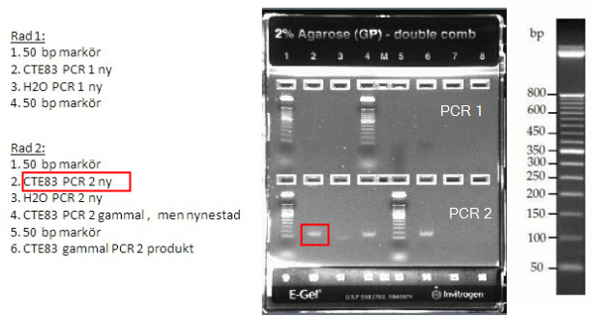

140624 Annelie Bjerkner